**DBMS Practical No.: 04**

**Name: yash ajay magar**

PR 4 * Execute DML Commands to manipulate data using SQL

**1. INSERT Command: Add Data (New Row)**

INSERT INTO emp (empno, ename, job, mgr, hiredate, sal, comm, deptno)

VALUES (101, 'yash', 'Manager', NULL, '2025-08-18', 90000.00, 5000.00, 10);

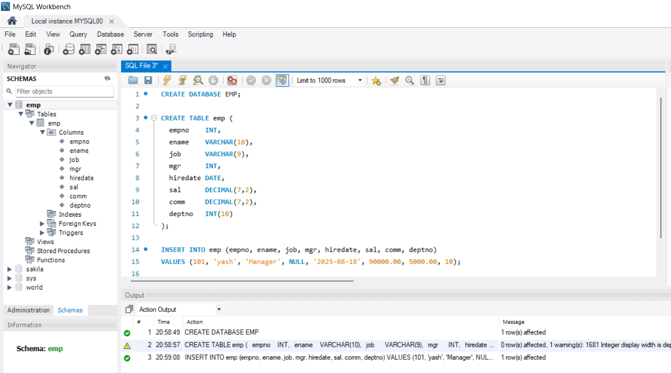

Explanation: Adds a new employee (yash) into the emp table.

**2. UPDATE Command: Change Existing Data**

UPDATE emp

SET sal = 95000.00, comm = 6000.00

WHERE empno = 101;

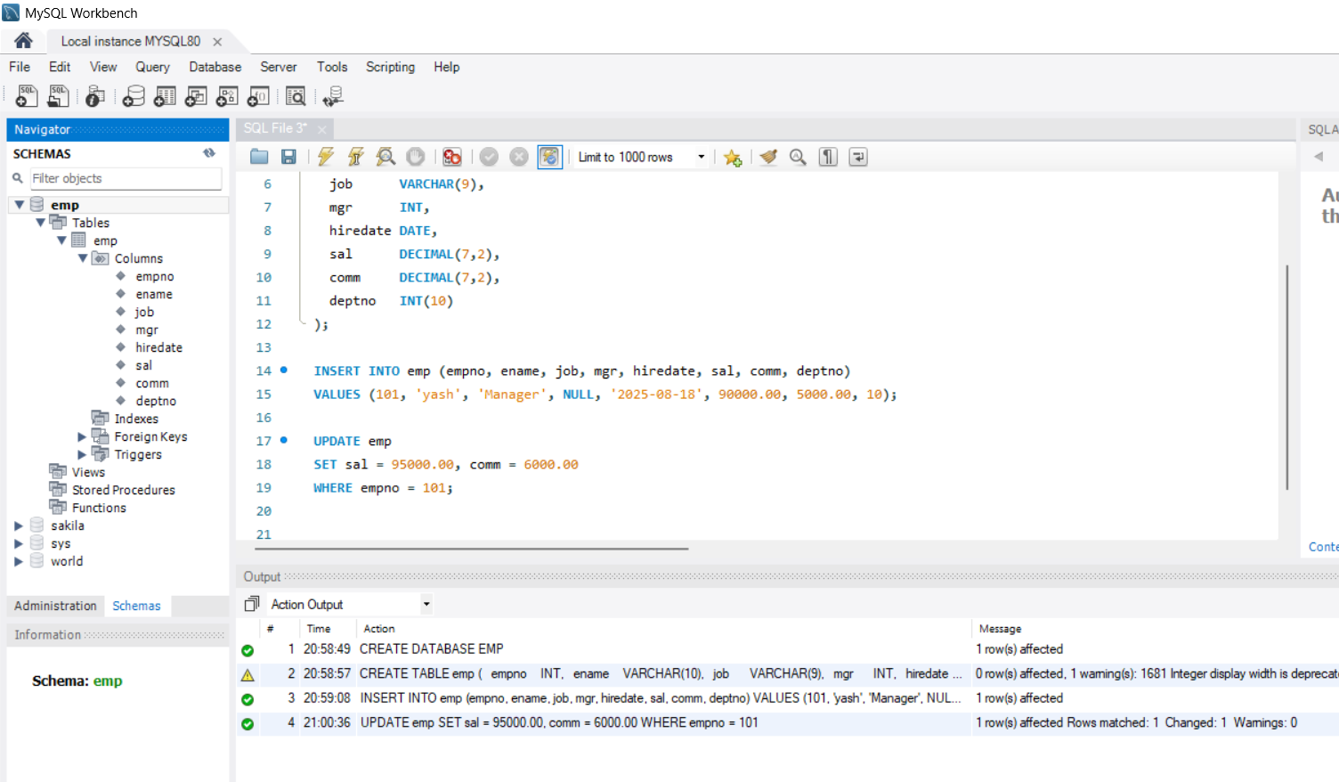

Explanation: Updates yash’s salary and commission.

**3. DELETE Command: Remove Data (One or More Rows)**

DELETE FROM emp

WHERE empno = 101;

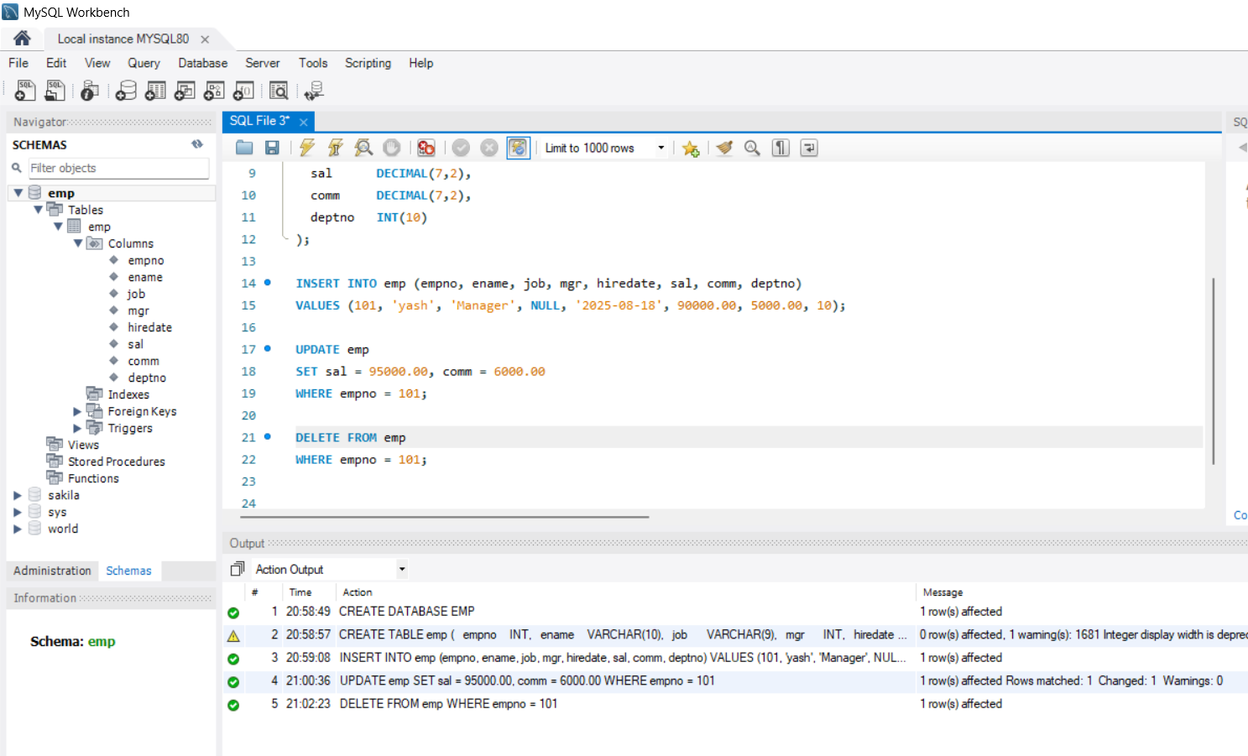

Explanation: Deletes the row where empno is 101.

**4. SELECT Command: Display Data (Read from Table)**

SELECT * FROM emp;

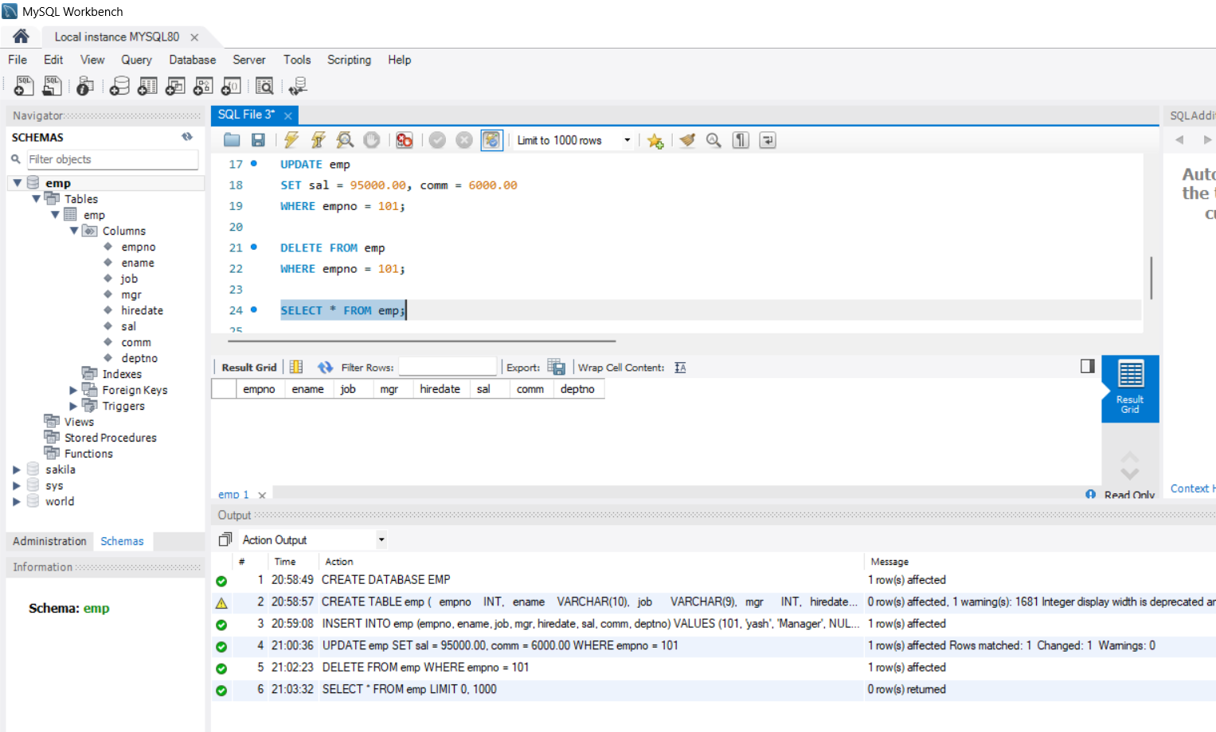

Explanation: Shows every row and column from the emp.